1

**Ms. Borders’ and Miss Eley’s Monthly Class Newsletter**

**April 11, 2023**



Dear Room 208 and 210 Families,

The Ohio state testing is this month. Both the Reading test and the Math test have two parts. We are super proud of the growth we have seen this year and look forward to an opportunity to show it! Tests will be administered in the mornings of these dates.

Tests are as follows:

***Borders/Eley Homeroom:***

**Reading Test**

Friday, April 14

Wednesday, April 19

**Math Test**

Tuesday, April 25

Thursday, April 27

***Kraft/Smith Homeroom:***

**Reading Test**

Wednesday, April 12

Tuesday, April 18

**Math Test**

Wednesday, April 26

Friday, April 28

As always, thanks for your support!

Ms. Borders and Miss Eley

[aborders@gcswave.com](mailto:aborders@gcswave.com)

heley@gcswave.com

(937)548-3185

Ways to help your third grader at home:

*Daily Practice of Math Facts

Third graders should have addition, subtraction, **and** multiplication facts mastered by the end of the school year. Math facts are the foundation for all other math skills and will make math easier for years to come. Try asking simple facts orally when you are in the car with your child. Ten extra minutes a day will make a huge difference!

*Telling Time

Practice makes closer to perfect! We have studied telling time with an analog clock. You can continue the practice with clocks at home. Third graders should be able to tell time to the nearest minute.

*Reading Daily

We cannot say enough how important reading each day is for young learners. Twenty minutes of reading each day makes a big difference in all school subjects and in life.

Looking Ahead

April 24-27

Kindergarten Screenings

May 2

PTA Meeting 6:00pm

May 17

Kids Read Now Event

5:oo pm – 6:30 pm

May 19

Dance Party & Kona Ice

May 26

3rd and 4th Grade Field Day

afternoon

May 29

Memorial Day

No School

May 31

Last Day of School for Students

Fourth Quarter Ends



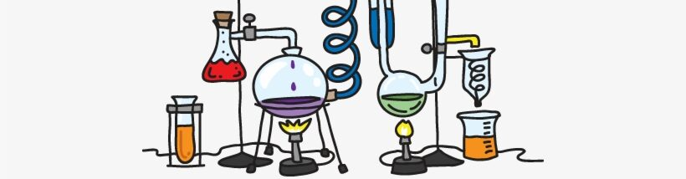

**Science and Social Studies**

In Science we did a STEM experiment with peeps. We have been working on measurement as well as other third grade Math skills for review.

Study of rocks and soil will begin mid to late April.

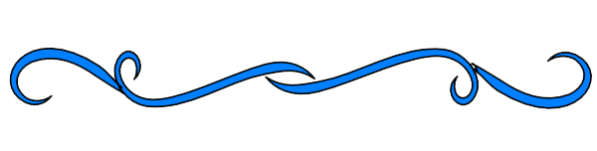

**March Wave Wonders**

**Aubrey Hubbell**

**Colten Hoyt**

**Both students are great examples**

**In April students are working to show trustworthyness.**